Assignment-3

|  |  |
| --- | --- |
| Assignment Date | 20 october2022 |
| Student Name | S Jegatheeshpathy |
| Student Roll Number | 913119104037 |
| Maximum Marks | 2 Marks |

Question-1:

1. **Create a Bucket in IBM object storage.**

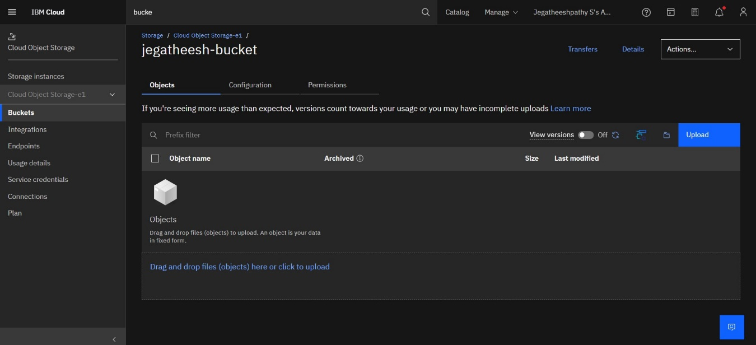

1. **Upload an 5 images to ibm object storage and make it public. write html code to displaying all the 5 images.**

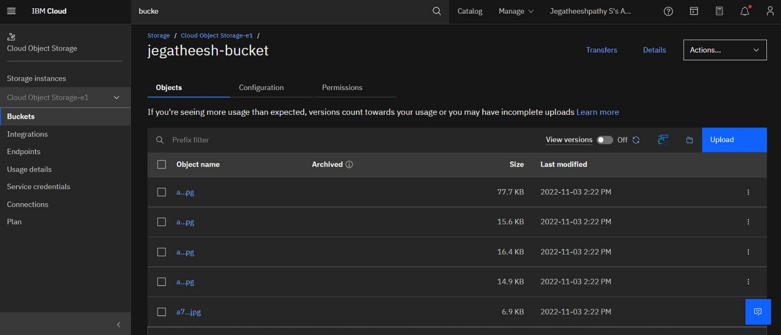

**3.Upload a css page to the object storage and use the same page in your HTML code.**

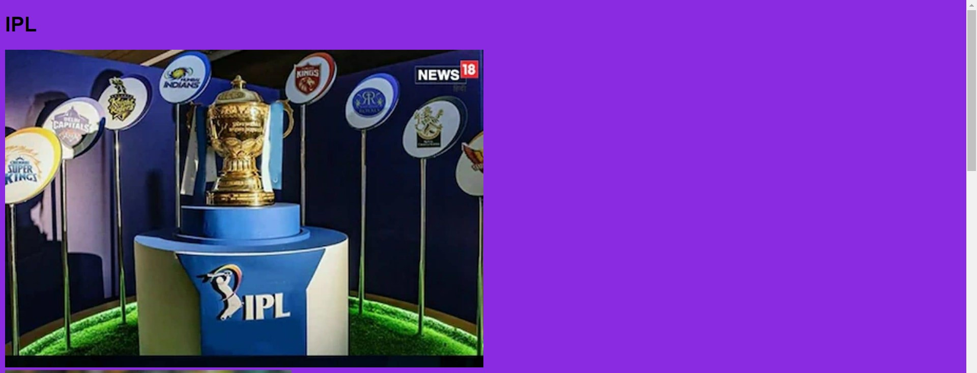

**4.Design a chatbot using IBM Watson assistant for hospital. Ex: User comes with query to knowthebranches for that hospital in your city. Submit the web URL of that chat bot as a assignment.**

https://web-chat.global.assistant.watson.appdomain.cloud/preview.html?backgroundImageURL=https%3A%2F%2Fau-syd.assistant.watson.cloud.ibm.com%2Fpublic%2Fimages%2Fupx-540c401f-842e-4866-b649-bb483cbf58f3%3A%3Abcf3dc1a-ae6e-4c8c-9ad7-22b05bc3db6c&integrationID=185012ab-ec8d-49be-9148-a7b6e32d5ac1&region=au-syd&serviceInstanceID=540c401f-842e-4866-b649-bb483cbf58f3

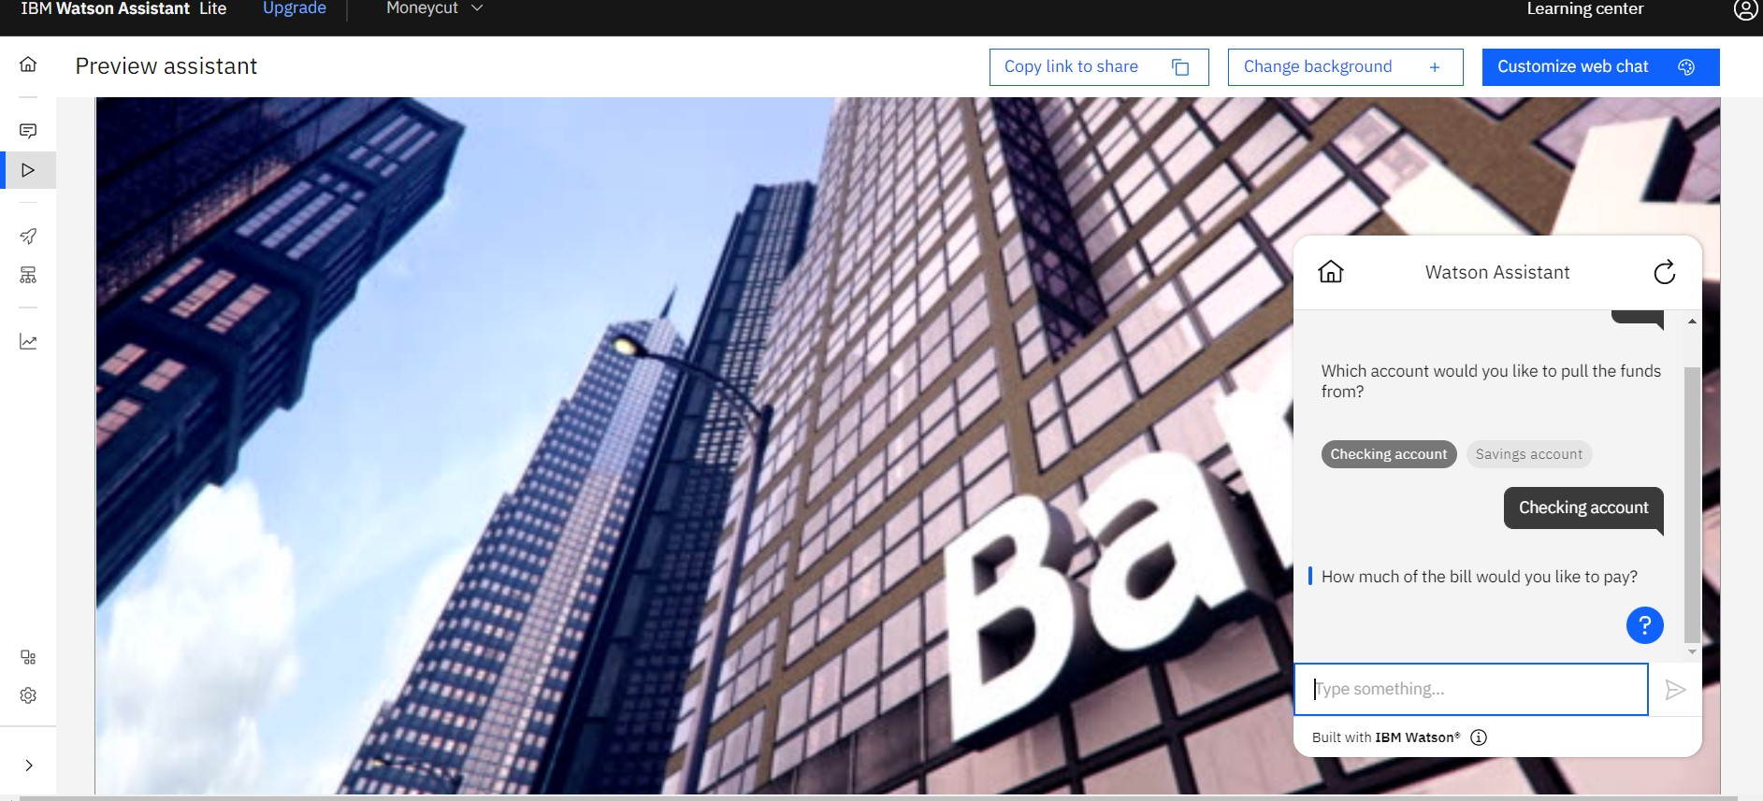

5.Create Watson assistant service with 10 steps and use 3 conditions in it. Load that script in HTMLpage.

